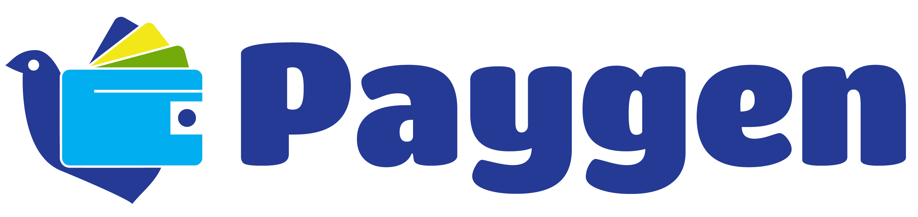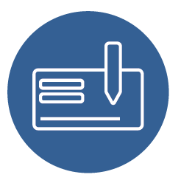

**Get in touch with us to learn more:**

[+19852359574] | [support@paygen.co] | [www.Paygen.co]

**Who should use ACH?**

Just about anyone who processes transactions is eligible to use the ACH network, but there are certain merchants who might benefits more than others:

* Inbound call centers
* Non-profit organizations that accept donations
* Insurance companies
* Property management companies/mortgage companies
* Subscription-based organizations
* Service-based merchants who use check conversion for in-person payments, such as doctors, lawyers, dentists and accountants

**Benefits**

* Lower transaction fees than credit/debit cards
* Increased profits due to reduced administrative costs
* Reduced fraud risk compared to paper checks
* Increased conversion by offering an additional payment option at checkout
* Encourages recurring billing

What is ACH and why should you care about it? The Automated Clearing House is designed to process batches of payments. ACH’s low fees make it the perfect choice for lower-value payments like utility bills, insurance premiums, mortgages, and other bills.

**Give more payment options to customers**

The rise of virtual transactions means it’s time to think beyond credit cards for payment acceptance. ACH lets customers pay directly from their bank, removing the middleman.

Not only does that mean it charges much lower fees than credit cards, but it also offers a great alternative to the growing number of millennials and other consumers opting out of credit card

use to avoid debt.

**Reduce transaction costs and streamline cash flow**

ACH payments