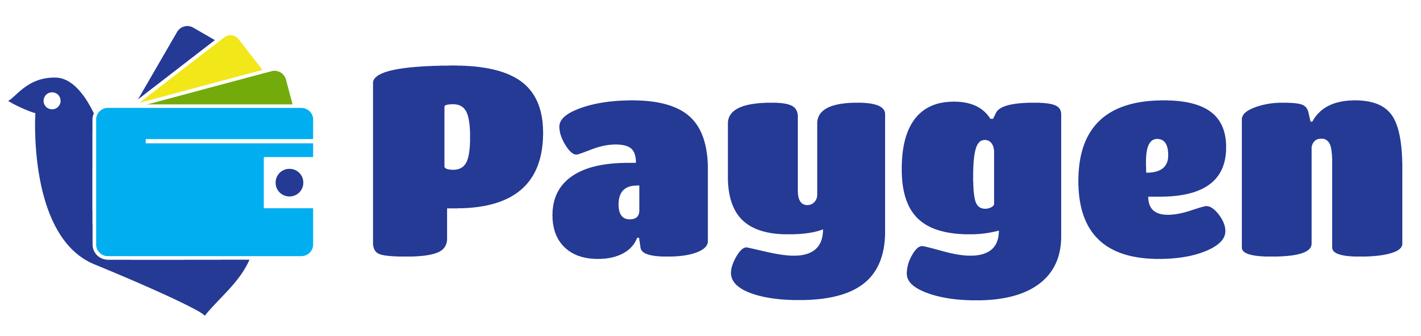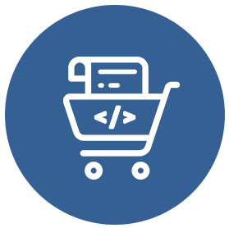

**Get in touch with us to learn more:**

[+19852359574] | [support@paygen.co] | [www.Paygen.co]

**Start accepting payments in minutes**

**Why Collect Checkout?**

**Flexible**

* + Give your customers a quick way to pay for goods and services or donate   
    to charity

**Easy to integrate**

* + Add a checkout button to your website, no coding necessary

**Contactless payments**

* + Offer contactless payments without a card reader via QR code

**Secure**

* + Reduce PCI compliance headaches by keeping sensitive credit card details off your servers

**Simple but powerful**

* + Sell any products from your account, and include tax, discounts and images

**Optimized checkout**

* + Improve conversion with a streamlined checkout process

**Support for multiple currencies**

* + Sell in your native currency

Collect Checkout lets you easily accept payments on your website or via email without ever touching a line of code. Quickly generate checkout buttons or custom links that go to a secure, conversion-optimized checkout page.

Collect Checkout